**Online catalog**

* You can find the online catalog here: <https://www.librarything.com/catalog/UIUCSpanPort>
* The books in the catalog are mainly from Dara’s Collection, but there are also other books and some old dissertations. To switch between collections, click “Dara’s Collection” tab on the top right.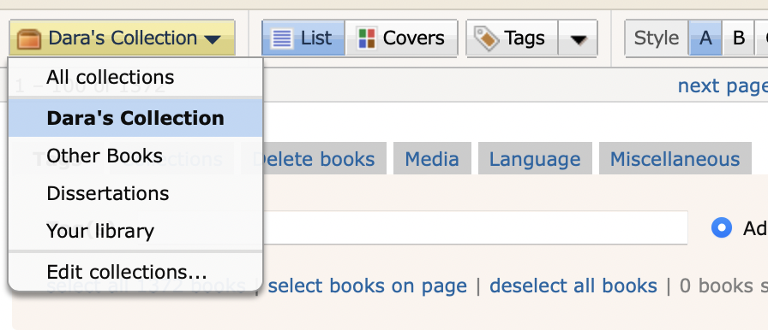
* Browsing the catalog by tags is recommended. To do so, click on the tab next to the covers tab.

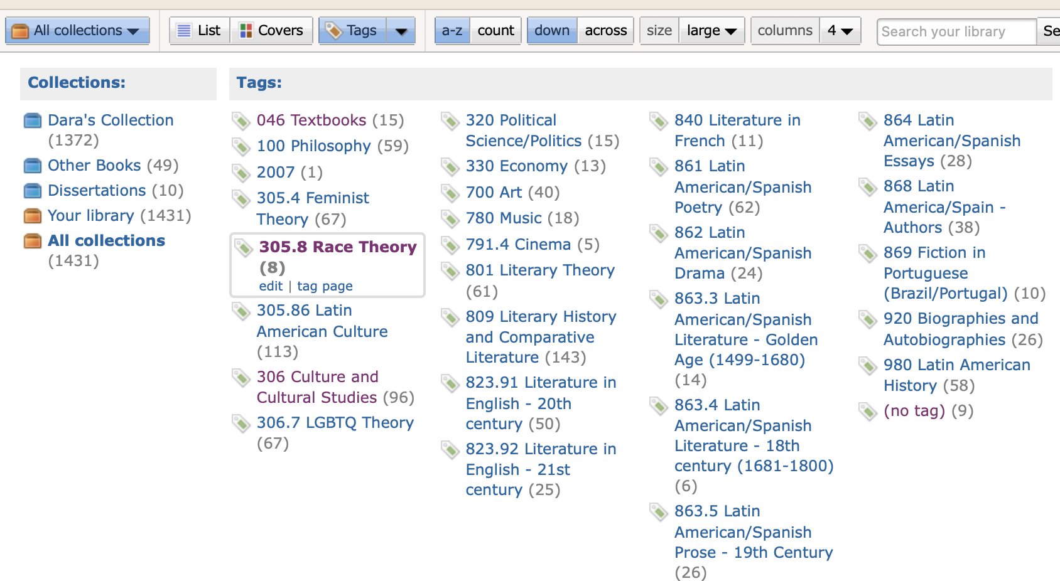

**Library use**

* You can read the books in 4136, take them to 4080 to scan them, or check them out. Please do not take the books home without checking them out.
* To check out a book, first locate it in the library using the library map to find it (library map available on the department’s website and at 4136). To ensure you aren’t interrupting a meeting in 4136, please check the schedule of the room here <https://apps.atlas.illinois.edu/SLCLrooms/Calendars/Calendar.aspx?calendarId=222>
* Then, bring the book to Mike Marino (4080C LCLB, available on weekdays between 8:30 am and 4:30 pm approx.) You must check out the book in person.
* You can check out each book for a 4-week loan period and you are allowed one renewal of 4 weeks. To renew the book, you can email Mike Marino ([mpmarino@illinois.edu](mailto:mpmarino@illinois.edu)).
* To keep track of your due date, search for the book you have checked out in the catalog and look at the lending column. It will display your name, the date in which you checked out the book, and the day on which it is due.

* To return the book, bring it back to Mike Marino’s office. If Mike isn’t there, you may leave it in his mailbox in 4080.
* Please treat the books with care. You will be responsible for the costs of replacing any book in your possession that is damaged or lost.

**Cataloguing system**

Some notes to consider regarding the way the library has been cataloged:

* The books are cataloged following a simplified version of the Dewey Decimal System.
* Due to the number of books, some categories are very broad (example: “700 Art”), while other categories (such as “860 Literature in Spanish”) are divided into many subsections.
* Please note that in the Dewey Decimal System, the literature sections (800) are divided by the language the works were originally published in.
* There are two sections with oversized books that couldn’t be alphabetically organized, 700 Art and 980 Latin American history (the oversized books are at the start of the shelf, the rest of the section is alphabetically organized)

**Catalog sections**

|  |  |  |
| --- | --- | --- |
| **Number** | **Category** | **Description/Further Information** |
| 046 | Textbooks | For language and culture teaching. |
| 100 | Philosophy |  |
| 305.4 | Feminist Theory |  |
| 305.8 | Race Theory |  |
| 305.86 | Latin American Culture | Both this and the next section include topics such as sociology, anthropology. |
| 306 | Culture and Cultural Studies |  |
| 306.7 | LGBTQ Theory |  |
| 320 | Political Science/Politics |  |
| 330 | Economy |  |
| 700 | Art | Includes painting, photography, architecture, etc. |
| 780 | Music |  |
| 791.4 | Cinema |  |
| 801 | Literary Theory |  |
| 809 | Literary History and Comparative Literature | Includes Literary Anthologies. |
| 823.91 | Literature in English - 20th century |  |
| 823.92 | Literature in English - 21st century |  |
| 840 | Literature in French |  |
| 861 | Latin American/Spanish Poetry |  |
| 862 | Latin American/Spanish Drama |  |
| 863.3 | Latin American/Spanish Literature - Golden Age (1499-1680) |  |
| 863.4 | Latin American/Spanish Literature - 18th century (1681-1800) |  |
| 863.5 | Latin American/Spanish Prose - 19th century | The prose subsections include mostly fiction, but also some non-fiction. |
| 863.62 | Latin American/Spanish Prose - 20th century (1900-1945) |  |
| 863.64 | Latin American/Spanish Prose - 20th century (1946-1999) |  |
| 863.7 | Latin American/Spanish Prose - 21st century |  |
| 864 | Latin American/Spanish Essays |  |
| 868 | Latin America/Spain Authors | Books that discuss the works of Latin American/Spanish authors. |
| 869 | Fiction in Portuguese (Brazil/Portugal) |  |
| 920 | Biographies | Also includes autobiographies. |
| 980 | Latin American History | A couple of books on Peninsular Spanish history are included here for simplicity’s sake. |